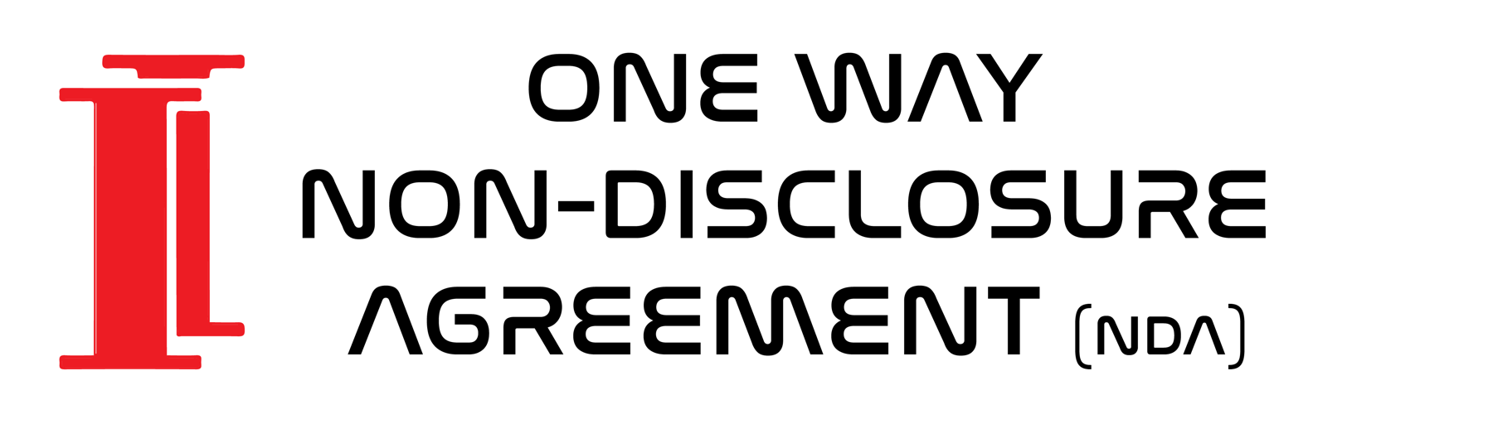

This one-way non-disclosure agreement (“the Agreement”) is made effective on the of 27th of August 2019 between:

Insula Investment Management Ltd., a company registered in England under company number 11731230 whose registered office is at Aldwych Chambers 6, 29 Essex Street, London, United Kingdom, WC2R 3AT
(“the Company”) and
x of Masey Mews, Effra Road, Brixton, London, United Kingdom, SW2 1AG
OR
[Company], a company registered in [England] under company number [number on Register of Companies] whose registered office is at [address of office on the Register of Companies]
(“the Recipient”).

- Purpose of the Agreement
The Agreement governs the disclosure of information by the Company to the Recipient for the purpose of working for the Company (“the Purpose”).

- Confidential Information
“Confidential Information” shall refer to any and all technical and non-technical information that the Company provides to the recipient, whether in visual, electronic, written or oral form and including but not limited to patent applications and other filings, trade secrets, and any other proprietary information as well as any ideas, techniques, sketches, drawings, works of authorship, models, inventions, know-how, processes, algorithms, software programs, documents and also any information concerning any research, experimental work, development, design details and specifications, engineering, financial information, purchasing, customer lists, investors, business and contractual relationships, business forecasts, sales and merchandising, or marketing plans of the Company and any information the Company provides regarding third parties.

- Non-Disclosure
The Recipient agrees that at all times and notwithstanding any termination of the Purpose, it will hold in strict confidence, and not disclose to any third party, any Confidential Information except as approved in writing in advance by the Company, and will use the Confidential Information for nothing other than the Purpose.

- Permitted Disclosure
The Recipient shall only permit access to the Confidential Information to others on a need-to-know basis for the same Purpose as specified above and if they are bound by similar non-disclosure agreements with the Company or are otherwise bound by confidentiality obligations to the Company at least as restrictive as those contained herein.

- Notice of Disclosure
The Recipient shall immediately notify the Company upon discovery of any loss or unauthorised disclosure of the Confidential Information.

- Use of Confidential Information
All Confidential Information is provided without any warranty of any kind. The Recipient recognises and agrees that nothing contained in the Agreement shall be construed as granting him any property rights, by licence or otherwise, to any Confidential Information, or to any invention or any patent, copyright, trademark, or other intellectual property right that has been issued or that may be issued, based on such Confidential Information. The Recipient shall not make use of or sell any product or service or any other item using, incorporating or derived from the Confidential Information, nor make any filings or registrations based on the Confidential Information, without express written approval of the Company.

- Return of Confidential Information
The Recipient will, on request from the Company, return all copies and records of the Confidential Information to the Company and will not retain any copies or records of the Confidential Information.

- No Reproduction
The Confidential Information shall not be reproduced in any form except as required to accomplish the Purpose. Any reproduction of any Confidential Information, idea or feature, shall remain the property of the Company.

- Sole agreement
The Agreement sets forth the complete, exclusive and final statement of the agreements between the Company and the Recipient as to the Purpose and supersedes all prior agreements, understandings, negotiations and/or discussions, whether oral or written, between the Company and the Recipient.

- Duplicates of the Agreement
The Agreement may be executed in duplicates, each of which shall be deemed an original and regarded as the same.

- Injunctive Relief
A breach of any of the obligations contained herein will result in irreparable and continuing damage to Company for which there will be no adequate remedy at law, and Company shall be entitled to injunctive relief and/or a decree for specific performance, and such other relief as may be proper (including monetary damages if appropriate).

- Competent jurisdiction
This Agreement is governed by, and is to be construed in accordance with, English law. The English Courts will have non-exclusive jurisdiction to deal with any dispute which has arisen or may arise out of, or in connection with, this Agreement.

The Recipient:

Place/date:

Signature:

For the Company:

Jules Becci-Morin de la Rivière
CEO and Founder

Place/ date: Flat 6,29 Essex Street, WC2R3AT, London,United Kingdom
Signature: JULESBDLR.

