First Name:
Middle Name:
Last Names:

Gender:
Nationality:
Date of Birth (DDMMYYYY):

Country of current residence:
Cell Phone number: +( )
WhatsApp number:
Personal Email:

Education
Institution | Major | Level* | Degree | Status** | Date Completed

Level* - 1) High School 2) Technical School 3) Community College 4) Post Graduate 5) University
Status** - 1) Complete 2) In Progress

Languages
The following information will be used to assist us in the maintenance of our Internal Language Directory. Please tell us your fluency in languages including English using the scale below.
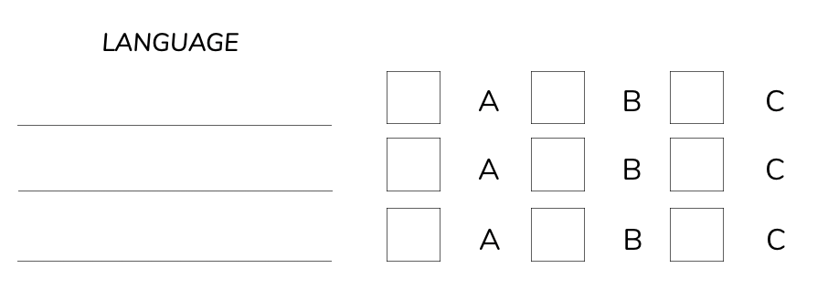

A - Fluent (speak, understand, write and read)

B - Very Well (speak, understand)

C - Limited (understand)

I certify the provided information is correct,

